4/6/2021

Abdelrahman Adel

Abdelrahman.adel.elsayed@gmail.com

AI Diploma

Assessment Three

Contents

Memory Address Python: 2

Mathematical precedence: 3

References 4

# Memory Address Python:

* To retrieve the memory address of any python object the function **id(object)** is used, it returns a unique number which changes every run of the program.
* To convert the returned id of the memory cell into its hexadecimal representation the function used is **hex(object)**
* So, the full instruction will be **print(hex(id(object)))**

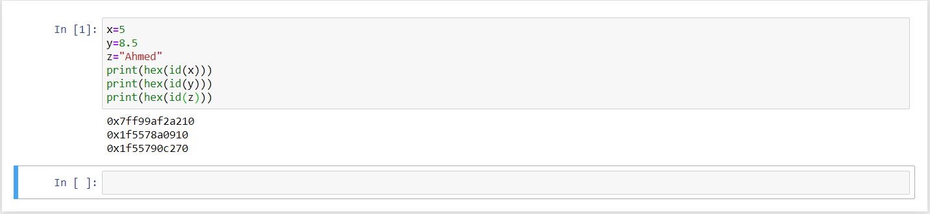

# Mathematical precedence:

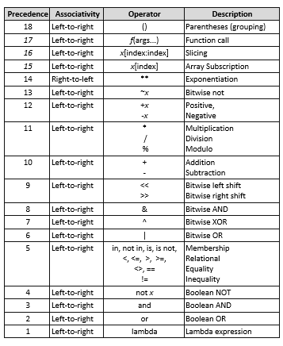

# References

|  |  |
| --- | --- |
| [1] | w3schools, "w3schools," [Online]. Available: https://www.w3schools.com/python/ref_func_id.asp. |
| [2] | GeeksforGeeks, "GeeksforGeeks," 15 10 2020. [Online]. Available: https://www.geeksforgeeks.org/python-hex-function/. |
| [3] | J. Cavin, "study.com," [Online]. Available: https://study.com/academy/lesson/python-operator-of-precedence.html. |